ASM LAB4
1. Write a program to display the numbers in decreasing order from 15 to 1

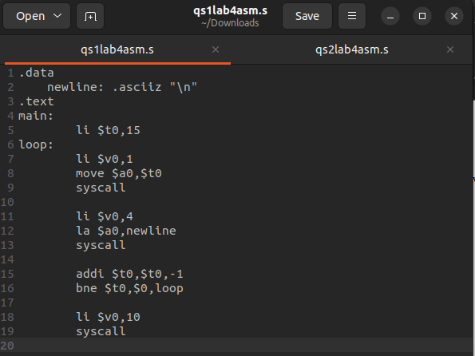
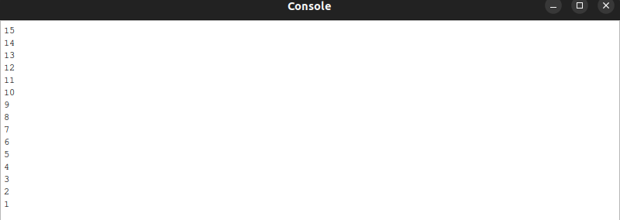

2. Write a program to read a number, display its multiplication table till 10
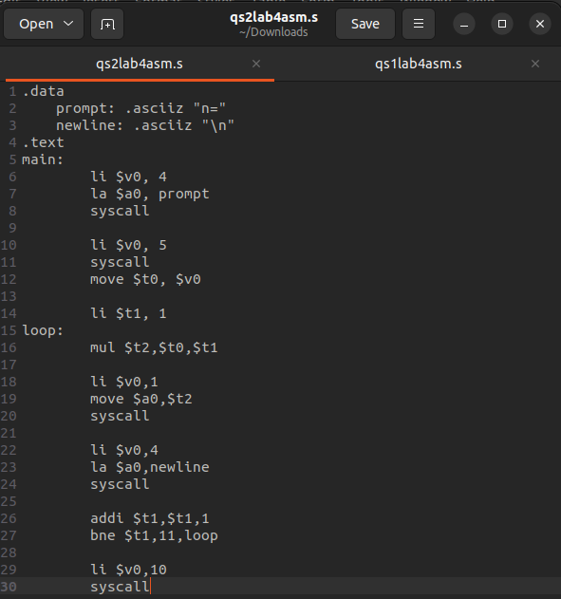
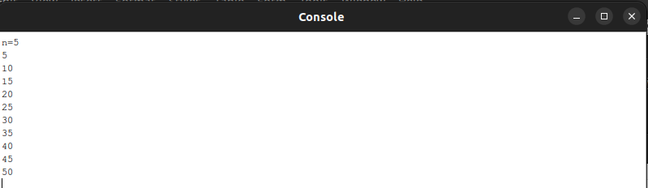
mips

